Brain College User Manual



For more Windows, Pocket PC and Smartphone games please visit
http://www.mastersoftmobilesolutions.com

User manual last updated: Oct. 20, 2008

Table of Content

(Use CTRL+Click to directly navigate to a chapter)

1. Welcome to Brain College 3
2. Brain College installation 4
3. Brain College registration fee 5
4. Training of the brain 6
5. Brain College main screen 10
6. Brain College Menu 12
7. Yearly exams 14
8. Year 5, Game 1: Classroom Cleanup 15
9. Year 5, Game 2: Fine Art 16
10. Year 5, Game 3: Operator Sums 17
11. Year 5, Game 4: Geography 18
12. Year 5, Game 5: Wordswap 19
13. Year 6, Game 1: Art of Zen 20
14. Year 6, Game 2: Tangrams 21
15. Year 6, Game 3: English 22
16. Year 6, Game 4: Physics 23
17. Year 6, Game 5: Blockholes 24
18. Year 7, Game 1: Sportsday 25
19. Year 7, Game 2: Timetable 26
20. Year 7, Game 3: Fractions 27
21. Year 7, Game 4: Tree Climbing 28
22. Year 7, Game 5: Backwords 29
23. Year 8, Game 1: Cubism 30
24. Year 8, Game 2: Some Squares 31
25. Year 8, Game 3: Common Room 32
26. Year 8, Game 4: Futoshiki 33
27. Year 8, Game 5: Computer Science 34

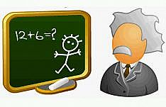
Welcome to Brain College

Dear student,

Welcome to Brain College!
After graduating from Brain School (available for Windows PC, Pocket PC and Smartphone), it is now time to commence the next phase in your education: Brain College. In Brain College you will have the chance to improve your brain, keep it ‘fresh’ and active, while having fun at the same time.

Brain College is open to all ages and you won’t need to purchase expensive books, pencils, calculators (no cheating!) and syllabi in order to participate. All you need is a device to play Brain College on, and a small one-time enrollment fee. If you choose to apply for Brain College, you will enroll in a four-year education that will take you through various courses. Among others your mathematical skills will be trained, your memory will be put to the test and you will have to solve puzzles. Every year you will need to take (and pass) an exam to prove that you have progressed and that you are capable of promoting to the next year. Only with true devotion, concentration and will power will you be able to get through the four years, but if you do, it will be rewarding. Brain College is a great way to tickle your brain and keep it fit!

The Brain College Board of Directors welcomes you, and we look forward to having you as our student!

Brain College installation
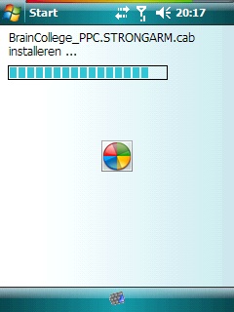
When you download Brain College, you will have an .exe file, a.cab file, or both. If you use the .exe installer, you need to have your device connected to your computer and connected through USB. Brain College will be installed using ActiveSync or Windows Mobile Device Center.

Alternatively, you can copy the .cab file to your device (by synchronizing the file) or download it to your device directly. Then open the .cab file directly on your device using your file explorer. This will also start the installation of Brain College.

Brain College registration fee


To enrol in Brain College, registration fees must first be paid!
You can purchase and pay for Brain College at:
http://www.MastersoftMobileSolutions.com

You will then receive a registration code which will allow you to enrol in Brain College for the full 4 years.

You will need to send your serial code (given under Menu > Register) to
Support@MastersoftMobileSolutions.com

Your professor will then send you a registration code back. (Please note that the professor is only present during college hours.) You can enter the registration code into the box, click 'register', and you will be done. Your years at Brain College can commence!

Training of the brain

If you’re interested in the backgrounds of the brain, this chapter will learn you a bit about the elements of the brain. Also described are the different aptitudes in which Brain College will train you.

BROCA’S AREA PARIETAL LOBE
FRONTAL LOBE

TEMPORAL LOBE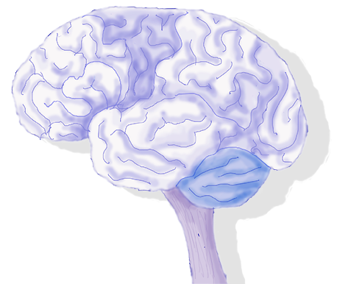OCCITIPAL LOBE

WERNICKE’S AREA

Diagram illustrating one side (hemisphere) of the brain’s cerebrum

The largest part of your brain is the Cerebrum; it’s rather like the cap of a mushroom that sits atop the other parts of the brain. It’s this part of the brain that has the heavily folded, ‘wrinkled’ appearance, designed as such so that as much brain material can be fitted into the small space inside the skull.
Its Frontal Lobe is involved in: speech, thought, emotion and skilled movement.
Behind the frontal lobe is the Parietal Lobe which perceives and interprets sensations such as pain, touch and temperature.
At the centre back is the Occipital Lobe which detects and interprets visual images.
On either side of the Cerebrum are the Temporal Lobes which are involved in hearing and strong memory.
The Cerebrum is split down the middle into 2 halves (Hemispheres) that communicate with each other. These are the left and right hemispheres which are responsible for different manners of thinking.

LEFT HEMISPHERE:
Dominant in right-handers
LOGICAL
SEQUENTIAL
RATIONAL
ANALYTICAL
OBJECTIVE
LOOKS AT ‘PARTS’

RIGHT HEMISPHERE:
Dominant in left-handers
RANDOM
INTUITIVE
HOLISTIC
SYNTHESISING
SUBJECTIVE
LOOKS AT ‘WHOLES’

Therefore right-handers are often more mathematical and analytical; whilst left-handers are more creative and intuitive. Personality also comes into play here though, so that is a generalisation! Even more up for debate is the male/ female divide and where that lies when it comes to language and mathematical skills for instance; there are some much generalised differences between the sexes, but more often than not these observations are unfounded stereotypes!

Your brain can be trained in several fields, and Brain College will help you in the following:

Mental Speed:
This is a big part of intelligence which can improve with practice and allow you to achieve your maximum potential for this skill. The faster your brain works, the more likely you are to have higher intelligence all round, as it can process all information with greater speed.
Numerical Aptitude:
Numeral-mathematical intelligence is at the centre of most everyday intelligence. Mental arithmetic when shopping or calculating your bank balances and finances for example. Although the frontal lobe and many areas of the brain are active whilst performing higher mathematics, for basic counting and number pattern tasks it is most often the left interior Parietal Lobe which is utilized. Exercising this aptitude most likely exercises your entire intelligence so could be one of the most effective forms of a mental workout!

Logical Aptitude:
Logical thought; although most often associated with high-flying chess players, is actually far more mundane and vital to your everyday life. This kind of thought is utilized when programming the video recorder for example! It’s commonly believed that this type of thought is mainly learnt, and in doing so you are better able to predict and spot problems and fallacies.
Memory training:
There are 2 main types of memory: working and long-term memory.
Working memory is almost like the brains chalkboard or note pad. Where ‘works in progress’ exist …. This is utilised for ideas, mid-way calculations in arithmetic, that sort of thing. A working memory that can hold more and hold that for longer will lead to greater intelligence all round as you can perform complex mental tasks faster and better.
Long-term memory is where information is stored that was in the working memory, but that you’ve either consciously tried to remember, has been ingrained over time or that has moved there because it has some emotional attachment to it. A memory goes through stages of ‘encoding’ in the process of being stored in your long-term memory. The stronger this encoding is, the more permanent that memory will be for you. You can help this encoding be stronger by using image associations, repetitions or story associations. For example, build your set of words you want to remember into a story of a journey with a series of images and related landmarks along the way!
Spatial Aptitude:
This is to do with visual experience, for example: forms, dimensions, patterns, shapes, movement, navigation and the space they are all contained within. It’s essential to everyday tasks as you use it to decide how long it will take you to do the shopping, plan a route to see a friend, decide where to put new furniture and how it will fit in your room! For this reason it’s useful to a wide range of professions: architects, artists, sportspeople, taxi drivers and engineers to name a few! It is often thought that spatial intelligence is the core of intelligence itself as it also probably governs mental space.
There is often much debate as to whether there is a gender divide in this aptitude! Some studies do show that males tend to be more proficient in this area, but it’s widely believed that far more significant than gender is individual personality, genetic inheritance, education and nutrition. There do seem to be differences as to the way the genders approach spatial awareness though. Women tend to use landmarks more during spatial tasks and are better at picture/ object recall and also finding first letters of words. Men however seem better on average at tasks that require mental rotation or manipulation of an object.
Verbal Aptitude:
This is a core component of overall intelligence. Those with a wide vocabulary and an ability to manipulate words, grammar and language are known to have a higher intelligence. Verbal training activates the areas in the Frontal and Temporal Lobes. Two of particular importance are; Wernicke's Area (located in the temporal lobe) and Broca’s Area (at the junction between the Frontal and Temporal Lobes). Verbal aptitude is relevant to a wide variety of careers: journalists, teachers and in marketing for example. It is also an aptitude that can significantly be improved with practice ….. hence the term ‘being well read’. Reading is an excellent way to practice, as is writing (such as keeping a diary); although there are many more!

Musical Aptitude:
At its most basic level, music is sound produced by different forms of vibration. This vibration creates sound waves which are converted to movement in the middle and inner ear. This movement is then further converted into electrical signals which then travel along the cranial nerve to the brain where its final processing takes place.
The fact that music has a profound affect on the brain has been acknowledged since ancient times. This profound effect is probably due to the fact that the brain’s handling of music isn’t localized to specific areas, but the sophistication of musical processing is all pervading. Listening to, and appreciating music is a complex process that involves memory, learning and emotions.
Most people are born with an innate ‘average’ skill in music, but all have the potential to achieve in it. Whilst a few are innately gifted, and a few fall in the other end of this scale, most are average in their musical potential. This aptitude can fluctuate most significantly up to the age of 9, depending on the richness and diversity of your musical environment - after this, what you are likely to improve and maximize upon is your ‘stabilized musical aptitude’ that was reached at this age. Mathematical Aptitude seems the single best predictor of Musical Aptitude, good at one; you are likely to be good at the other!

Studies have shown that listening to Mozart (Sonata for Two Pianos in D Major) can boost your brain function …. spatial reasoning has been shown to improve as a result. Improvement has even been shown with Alzheimer’s patients .. the resulting memory and other brain improvement have become known as ‘The Mozart Effect’! It is believed that musical and spatial processing use the same pathways in the brain. Music can be seen as a brain circuitry ‘boost’! Learning to play an instrument, however, rather than just listening is widely agreed to produce the most profound improvements in brain function.
Even though Einstein is widely regarded as one of the greatest minds who ever lived, he was actually dismissed from school due to being judged ‘too stupid to learn’. Unwilling to accept this, Einstein’s parents bought him a violin, and this was the key to the development of his amazing mind. Music was what Einstein himself credited for his intelligence. His favourites were the music of Bach and Mozart.


Brain College main screen

In the main screen of Brain College, you can see that your education has been split up into four years. Every year you will need to take five courses. Each of these courses are divided into 5 tests for each of which you can get a grade. The highest grade you can achieve is an A+, and this is the grade you will need to achieve for a certain amount of tests in order to unlock the exam for your current year.

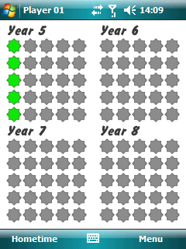

Main screen, divided into four years.

From the main screen, you can tap on one of the unlocked years to open the screen for that year in detail. You can then see the five courses (games) and the grades you have achieved already. Tapping on one of the colored stars brings you to that test (level) so that you can try to improve your grade and get an A+. The grey stars represent levels that still have to be unlocked by getting an A+ for the previous test.

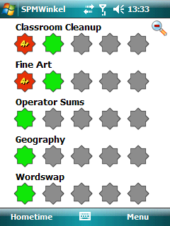

Year 5 with an A+ in the first test of both Classroom Cleanup and Fine Art.

In order to get access to the next year, you will need to get a certain number of A+ stars and pass the exam for your current year. In the exam your brain will be tested with questions from the different courses you’ve followed that year. The questions will be in random order and have to be answered in a short amount of time. This way, you are also tested on your stress resistance and ability to quickly jump between different kinds of problem-solving. The exams can be reached through Menu > Daily Exam.
Progressing to a higher year in Brain College doesn’t mean that you can no longer follow the courses from previous years: if you press the zooming glass in the Year view, you return to the Main view where you can select another year to play.

In both the Main and Year view, there are two soft-keys at the bottom of the screen. The left one is called Hometime and you can use it to close Brain College. The right soft-key will open the Menu which is discussed elsewhere in this user manual.


Brain College Menu

Pressing the soft-key in the bottom right will open the Menu. From there, all options in Brain College can be reached. Here you can change game settings and see your progress in Brain College.

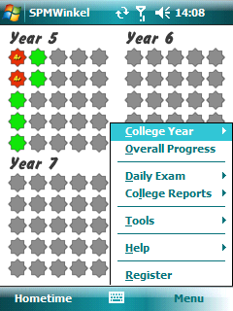

Brain College Menu

College Year – Select any of the years (5-8) to open the Year view. If you want to play
the previous years (1-4) you will need to purchase Brain School from Mastersoft Mobile Solutions.

Overall Progress - Open the Main view.

Daily Exam – Play any of the exams after unlocking them by achieving enough A+ stars.

College Reports
My Exam Results – Show a detailed graph of your progress in any of the four
years, or complete progress in all years combined.
My Score – Calculates your score based on your grades and the time you used to
achieve them. They can be grouped by grade (A+ to C) or by level (each game consists of five test levels).
Class – Shows a Highscore list of all players based on their score or exam results.

Tools
Options – Audio and Student settings.
Audio – Enable or disable the in-game sounds.
Student – Manage player accounts.
Change Student – Here you can choose from 10 players accounts.
In other words: you can play Brain College with 9 friends and everyone can save his/her own progress!
Edit Student’s Name – Change the player’s name.
Reset Current Student – Delete game progress of current player.
Reset ALL Students – Delete game progress of all players.
Backup Coursework – Create a backup of your progress in Brain College.
Restore Coursework – Restore a previously made backup of your Brain College
progress.

Help
About – Copyright information about Brain College.
Credits – Here you can see which great minds participated in the development of
Brain College.
Other Titles – Suggests some other software titles from Mastersoft Mobile
Solutions.
Feedback – Invites you to send feedback on Brain College to Mastersoft Mobile
Solutions.
How to Play – Gives some very basic information on how to play Brain College.

Register
Here you can register your copy of Brain College in order to enroll in all four years of education. The code given should be sent to Mastersoft Mobile Solutions so that a personal registration code can be generated for you.

Yearly exams

To graduate from Brain College, you will need to take exams at the end of each year. The exams are available from the menu (right soft-key), but need to be unlocked before they can be taken. In order to unlock the exam for each year, you will need to get a certain amount of A+ stars.
Note that the total amount of A+ stars are counted, so if you have problems with certain classes in Year 6, you can try getting some more A+ stars in Year 1 and unlock the Year 6 exam anyway.

The exams are designed to test your overall knowledge on the subjects you’ve had that year. It will include questions about several subjects in mixed order. If you answer enough questions correctly in the given amount of time, and not make more than the allowed amount of mistakes, you will pass the exam and unlock next year’s subjects!

Year 5, Game 1: Classroom Cleanup
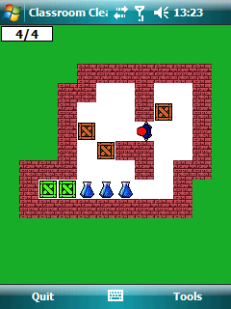
Classroom Cleanup is an implementation of the famous game Sokoban.

Goal of the game
You are the person with a blue shirt and red hair, and your goal is to move the brown crates on top of the blue flasks of chemicals. In every test the difficulty and amount of puzzles increases. However, there is no time limit.

Answer submission
Use the D-Pad on your device to get behind the crates. From there you can push the crates in the desired direction. The bottom right soft-key allows you to restart a level if you get stuck, undo your last move, or skip a level if you have already completed it previously.

Year 5, Game 2: Fine Art
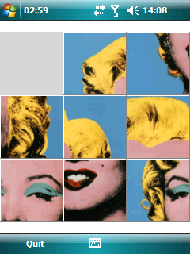
As a kid, it was a real challenge to solve the plastic 3x3 puzzles with only 8 pieces. Moving those pieces around until a correct image was reached, could take a long time. People who’ve played with such puzzles after their childhood will know that it still isn’t very easy to solve such a puzzle. Today, you’ll get to try again. But not only in 3x3 format. Oh no, they will get bigger…

Goal of the game
At first you get to see an image of a person, painting, etc. When you’ve memorized it, click “I’m done”. Then the image is divided in 3x3, 4x4, or 5x5 pieces which are shuffled across the screen. Then you need to move those pieces back in the correct order, using the empty spot as a place where you can slide puzzle pieces onto.

Answer submission
Use your stylus/finger to drag a piece to the empty spot. You can also tap a piece to move an entire column or row. For example, tapping on the bottom-left piece will move the two pieces in the left column up one place. Once the image is correct, the game automatically ends.

Year 5, Game 3: Operator Sums
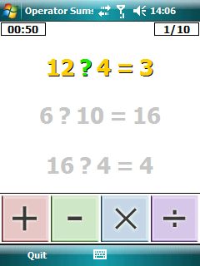
Can you still do quick calculations?

Goal of the game
We all know that 2 * 3 = 6, but if you see 2 and 3, do you know what to do to them in order to get 6? Answering that question is the goal of this game. This might not seem difficult, but the pressure of the time ticking away and the switch from making calculations to pressing the right button makes this game harder than you think.

Answer submission
Simply tap the button that represents the operator that is needed to complete the calculation.

Year 5, Game 4: Geography
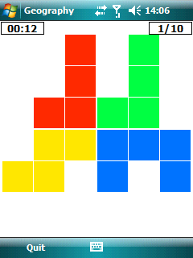
Can you see the continents in the image to the right? With a lot of imagination, perhaps. However, that is what this game is based on. Quickly see which continent is the largest, and you proceed.

Goal of the game
Here you simply need to see which of the areas is the largest. In other words: which color do you see the most? In this example, there are six red blocks, five yellow blocks, and four green and blue blocks. Therefore, the answer would be “red”. Sounds easy? Sure, when you’ve got the time to count. However, this game is not about counting, it’s about quickly analyzing information on the screen. You won’t have the time to count all the blocks, you need to immediately see the relative proportions of all “continents” and choose your answer. Even more because the amount of blocks increases with every level, so there will simply be too many blocks to count.

Answer submission
Tap your stylus/finger on the section with the color that you think represents the largest continent. So in the example above, you need to tap anywhere in the top left quarter of the screen.

Year 5, Game 5: Wordswap
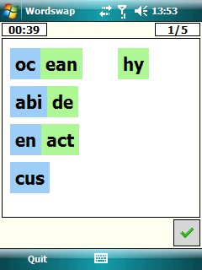
This game may be hard for non-native English speakers. However, they can also look at this game as a challenge, and use it to expand their vocabulary.

Goal of the game
You are given a certain number of words, which are cut in half. Your task is to combine the first elements of the words (on the left), with the missing elements (from the right). Create correct English words, and you’ll proceed.

Answer submission
Use the stylus/finger to drag a green piece to a blue piece, in order to create a word. If you made a mistake, simply drag the green piece back to the right. When you’re done, tap the green tick to submit your answer. You’ll have to complete several screens in order to finish a level.

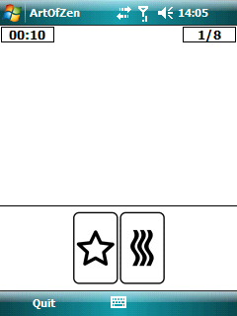
Year 6, Game 1: Art of Zen

Be sure to have your sounds enabled for this game!

Goal of the game
Listen to the assignment when it is given to you through the speakers. Then repeat the spoken steps by tapping on the correct images. For example, “Star, Wave” would result in tapping the image with the star first, followed by tapping the image with the waves.

Answer submission
Tap the images in the order that you are told.

Year 6, Game 2: Tangrams
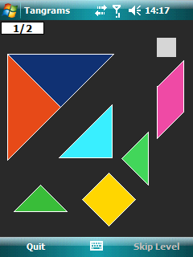
Many people will know the traditional game of Tangram. You use seven pieces to create all kinds of shapes, from a simple square to a complicated swan.

Goal of the game
You need to create the image that is displayed in the top right corner (in this case: the grey square). You need to use all seven pieces provided to you, and they cannot overlap.

Answer submission
You can use your stylus to drag pieces to the desired location. Tap the corner of a selected piece and drag your stylus across the screen in order to rotate it. Pieces cannot be mirrored/flipped.
If the pieces are a few pixels away from easy other they might “snap” together so very small mistakes may be corrected. If you have already completed a puzzle in the past and want to move on to a later puzzle in the current level, press the right soft-key “Skip Level”.

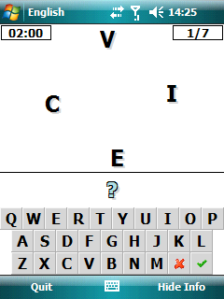
Year 6, Game 3: English

Another language-based game. Can you re-order the letters to create a correct English word?

Goal of the game
Analyze the rotating letters and rearrange them in your mind. If you’ve found a word that can be created with these letters, enter it. In this example, the word “vice” is correct.

Answer submission
Type your answer using the on-screen keyboard. Submit your answer with the green tick. If you’ve made a typing error, clear your entry using the red X. Solve several screens correctly within the time limit in order to get an A+ rating.

Year 6, Game 4: Physics
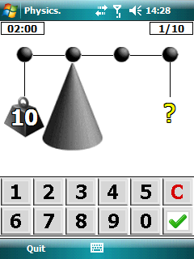
In Physics it is all about balance. How much weight do you have to attach to the scale to make it perfectly balanced?

Goal of the game
You need to calculate how much weight needs to be attached at the place of the question mark. The rule that applies here is that a weight that is located twice as far from the cone, has twice the downward force. So in the image to the right, you could add 10 to the weight at the immediate right of the cone (the third out of four balls, if you count from left to right) in order to make the scale balanced. However, the question mark is one position further to the right. And there, in order to create the same downward force, the weight you hang there will only have to be half the weight. So the answer to this question would be 10 / 2 = 5.
The formula for this is:
moment = F * d
where F is Force and d is the distance to the centre. In this balance, the moment on the left and right need to be in balance so that:
moment_{left} = moment_{right}
or, for the example image:
F₁ * d₁ = F₂ * d₂ + F₃ * d₃
where ₁ is to the left of the center (the weight with 10), ₂ is to the right of the center (which is currently empty) and ₃ is the place with the question mark.
Filling this in would give:
10 * 1 = 0 * 1 + ? * 2
and to solve this:
10 = 0 + ? * 2
10 = ? * 2
? = 10 / 2
? = 5

Answer submission
You need to use your stylus/finger to enter the correct weight. Use the green tick button to confirm your answer, or the red C to clear your answer and undo a typing mistake.

Year 6, Game 5: Blockholes
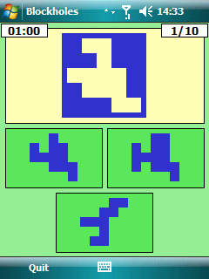
Most people have played with puzzles where you need to push shapes through holes. Even though you know that a triangle won’t fit through a rectangular shaped hole, it’s always fun to try! With Blockholes however, it’s not that easy to see if a shape fits or not. Also, you don’t get to try: you just have to submit the correct answer.

Goal of the game
Figure out which of the possible solutions can be placed in the empty section of the image above. Feel free to turn your pieces, only one will fit. Try to find some elements of the assignment image that stand out, and see which of the possible answers matches.

Answer submission
Tap on the piece that can be placed in the hole in the assignment image.

Year 7, Game 1: Sportsday
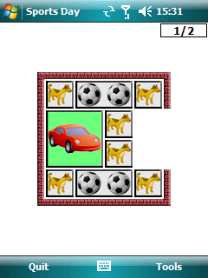
This will be the favorite of many. You own a large sports car and want to drive away. However, your road is blocked by various obstacles. Move them around to clear the path for your sports car.

Goal of the game
The goal of Sportsday is to move your car in front of the opening so that it can drive away without problems. To do this, you need to move around the car and the obstacles in the playing field.

Answer submission
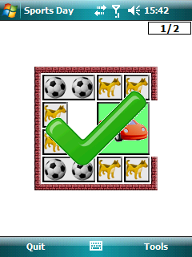
Use your stylus/finger to drag the blocks with obstacles out of the way. You can also move your car. Reach an end result where the car is directly in front of the opening, like the image below. If you get stuck, you can Restart the puzzle through the Tools menu, and if you’ve already finished the puzzle previously you can Skip it.

Year 7, Game 2: Timetable
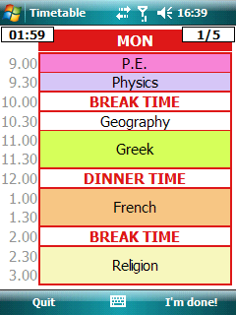
Part of going to college, is having to deal with timetables. After several weeks of college, it would become rather easy to remember which subjects you had on a given day. But can you also remember your timetable in just two minutes?

Goal of the game
The goal is to store the timetable that you are given, in your memory. Then you’ll get a number of questions about this, and you’ll have to answer which lesson you should attend at the given time.

Answer submission
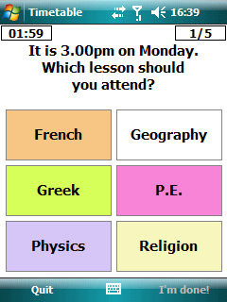
Tap the lesson that you should attend at the given day and time.

Year 7, Game 3: Fractions
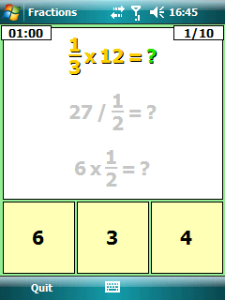
Everybody loves fractions!

Goal of the game
There really is no story behind this game. Dig deep into your memory and recall the lessons about fractions. Can you solve various fractions within the time limit?

Answer submission
The good part of this game is that it is multiple choice. So all you need to do is pick the correct answer, and tap it.

Year 7, Game 4: Tree Climbing
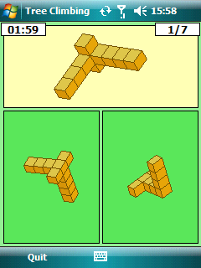
How good is your 3D vision, and can you easily rotate objects in your mind?

Goal of the game
At the top you get to see a shape, and at the bottom there are several constructions of which only one is an exact replica of the shape at the top. In the example, the image at the top has a point in the middle where all blocks come together, while the answer at the bottom right doesn’t. So the only correct answer can be the first image (on the left), because it’s the same shape, just rotated.,It has all the blocks at the same place as the image at the top.

Answer submission
Simply tap on the image with the same shape as the one at the top.

Year 7, Game 5: Backwords
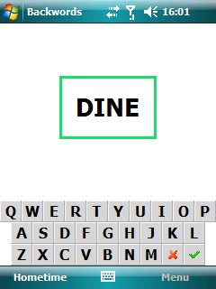
Listen to the word, turn it around, and enter it!
That’s what Backwar – ehm... Backwords is all about.

Goal of the game
Turn on the sounds of your device, and listen to the word you hear. You can also see it flashing on the screen for a very brief moment. Spell it, turn around the letters, and enter it. So the word “DINE” would become
E N I D

Answer submission
Type the letters on the on-screen keyboard. Remember to type the word backwards!
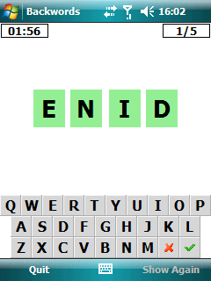
Tip: If you weren’t able to see the word the first time, tap “Show Again” (right softkey) to let the word re-appear on the screen for a very short while. This will only work if you didn’t start typing already.

Year 8, Game 1: Cubism
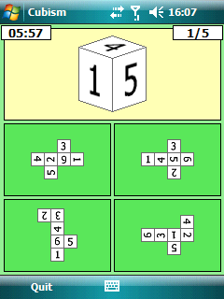
Have you ever created a die out of a piece of paper? And if so, did you already paint the dots on them before you actually constructed the die in 3D? If so, you’re in a real advantage with this game!

Goal of the game
The die is actually the inspiration for level one, but in later levels you’ll also see other marks on the sides of the cube. Your task is to open up the shape in your mind and visualize how it would look in 2D.
In this puzzle, the 1 would have to be directly beneath the 4. This is impossible in the solution at the bottom left.
In the solution at the bottom right, the 1 is directly below the 5, so you can eliminate this one too. Finally, in the solution at the top right, the 4 is below the 1, so that only leaves the solution at the top left. This is the correct answer.

Answer submission
Simply click the image of the 2D view that can create the cube displayed at the top.

Year 8, Game 2: Some Squares
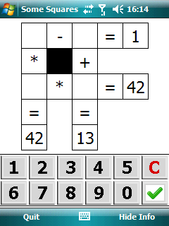
Figuring out that 42 is the product of 7 and 6 is not so hard. And 13 can be reached with quite a few combinations of numbers. However, if you add four calculations like this and put them in a square, you get an interesting strategic puzzle.

Goal of the game
Fill in the empty blocks so that all four calculations are correct. In the example, 42 is either 7*6 or 6*7. You’ll have to enter this twice (vertically in the first column, horizontally in the second row). So you could use 6*7 for the vertical sum, which would leave 7*6 for the horizontal sum. However, that would give you a problem finishing the puzzle, since 6-?=1 would make you put 5 in the empty field, but 5+6 is not 11. So you turn around the sums that you used to reach 42. Put 7 in the top left and bottom right field, 6 in the bottom left and top right, and you’ll have a correct solution.

Answer submission
Tap the box in which you want to submit an answer and then tap the number. Correct a mistake with the red C. You don’t really need the green tick in this game since your answer is automatically checked.

Year 8, Game 3: Common Room
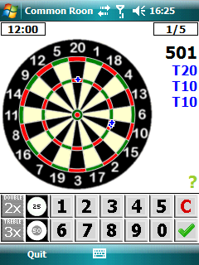
LET’S… PLAY… DAAAAAARTS!!!

Goal of the game
First, three darts are thrown for you. They’re both indicated on the dartboard and listed at the right. You need to calculate their value and subtract that from the black value at the top. In the example, you’ve thrown 3*20 + 3 * 10 + 3 * 10 = 120. Subtract this from 501 and the answer you need to submit is 381. In the second round you need to subtract the three darts value from this (381).
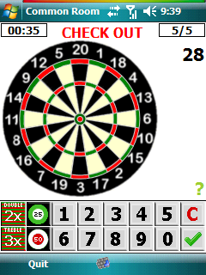
Eventually you get to the second element of the game: Check Out. A small amount of points is left, and you need to find the darts that you can use to throw that score. You always need to end with a Double (2x). In the example below, a possible solution would be Multiple answers are possible.

Answer submission
Submit the answer on the on-screen keyboard. Submit “Double” and “Triple” (2x and 3x) and BullsEye and Single Bull (50 and 25, the center of the dartboard) with the dedicated buttons.

Year 8, Game 4: Futoshiki
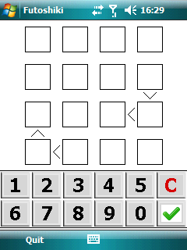
Most people know Sudoku by now. So do we. Therefore, we’ve moved on to a new kind of puzzle: Futoshiki.

Goal of the game
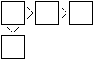
Like Sudoku, you need to fill each row and column with numbers, and each number may only appear once in each column and row. In Futoshiki, there are arrows between some fields that indicate the relative magnitude of the numbers. The > “larger than” sign means that the number at the “opening” is larger than the number at the “tip” of the character.

Answer submission
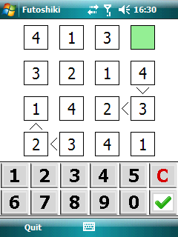
Tap on the field you want to enter a number in. Then tap on the number to enter it.
(The allowed number depend on the size of the grid. In this example, you can only use the numbers 1, 2, 3 and 4.)

Year 8, Game 5: Computer Science
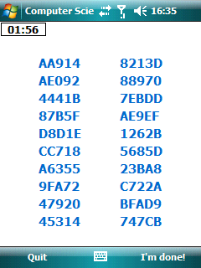
This one is going to hurt. How many hexadecimal numbers can you remember?

Goal of the game
Try to memorize as many hexadecimal numbers as possible. (If you’re ready within the given time, you can press the right soft-key “I’m done!”)
Begin with the easiest number, try to find tricks to remember them, do whatever it takes to remember as much as you can.

Answer submission
Use the on-screen keyboard to enter your answers, and press the green tick to submit a word. Use the red C as backspace key if you want to clear your entry.
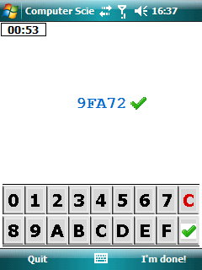
Note: You will not see your previously submitted answers!

